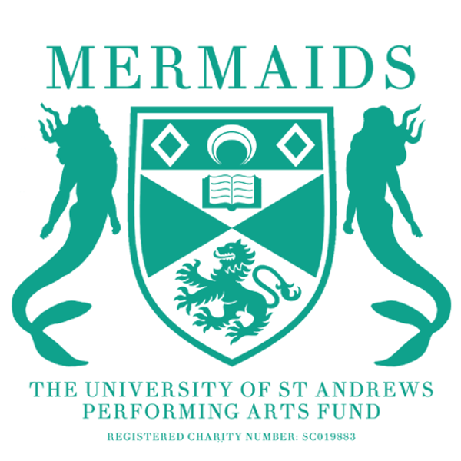

VENUE INFORMATION

Barron Theatre
- Seats: 54
- Dates: Available Weeks 0-11. Choice between two and three nights, though three night shows may be reduced to two at committee discretion. Dates may similarly shift.
- Cost: £1 per ticket sold (built into the budget spreadsheet)
- Contact barron@st-andrews.ac.uk with questions about the venue.

Byre Main Space
- Seats: 216
- Dates: TBD
- Cost: c.£300 per night, plus get-in day, as well as a 20% profit split (plus extra cost for flying, etc. Get in contact with committee if you think your production will need extra technical support.)
  - Two nights is recommended, as attendance is difficult to achieve across three, lowering the show's potential to break-even.
- NB: Do not contact the Byre directly. Let Mermaids handle any conversations about booking the Byre space, INCLUDING extending or altering bookings.

StAge (Union Performance Space)
- Seats: 132
- Dates: Mermaids has not pre-booked any Venue 1 spaces, so it is up to individual production teams to contact the Union and secure a slot. Please make sure the Union is aware it is a provisional booking, and it will be confirmed after we have had the proposal meeting.
- Cost: £100 per night.

