PRODUCTION / ACTIVITY:

DATES OF ACTIVITY: | ASSESSMENT DATE:
ASSESSED BY:  CONTACT: | APPROVED BY:  DATE:
Activity | Hazard  List hazards here | Who might  be Harmed  list persons | Initial Risk  Rating  S x L | Control Measures  What are you doing to mitigate against the risk | Risk Rating  S x L | Further  Action Required
 |  |  |  |  |  | None

Method of Communicating assessment: Building induction / Senior Members of team on shift during intial shifts

Signed:

RISK ASSESSMENT - GUIDANCE NOTES

action | Hazard  (Something with the potential to cause harm) | Persons At Risk  (Someone at risk from the hazard) | Is The Risk Adequately Controlled  (What are the existing controls) | What Further Action Needed to Control Risk  (What more could reasonably be done)
Examples | *Examples | *Examples *Particularly | *Examples
Crowd safety  Access equipment  - Ladder  - MEWP  Using electrical item  - Tools  - Lighting  - Sound  Fit ups  - Unloading vehicles  - rigging  - Building set  - Manual  Working on a rake  Working outside | Slippage / Tripping  Fire (flammable substances)  Ergonomic  Moving Parts  Working at Height  Vehicles  Electrical wiring  Noise  Manual handling  Fumes  Dust  Chemicals | Office Staff  . Freelancers  Audience  Cleaners  Maintenance  *Contractors  *Visitors  The Public  Operators  *Young  *inexperienced  *Trainees  *People working alone  *The Disabled | Is there adequate information / training?  Are there adequate systems / procedures?  Meet legal requirements?  Meet Byre Standards?  Comply with industry standards?  Represent good practice?  Reduce risk as far as possible?  * Are you doing all that is reasonably practicable?  * Can I eliminate the hazard?  * If not, how can I control the risk?  * Personal protective clothing should only be used when no other reasonable action exists | * Prioritise for risks affecting large numbers or where serious harm may result  * Consider:  - Remove risk completely  - Try less risky option  - Prevent access to hazard, e.g. guarding  - Reorganise work to reduce exposure  - Issue personal protective clothing  - Welfare facilities - Washing / First Aid  - Administrative controls  * Review with Management. Assign Responsibility and timescales.

Risk Index - Calculated by multiplying Severity (S) of Hazard by Likelihood (L) of it occurring

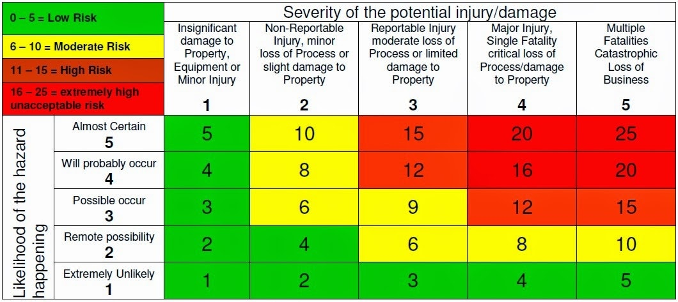

I confirm that the significant findings of the assessments in this file have been communicated to me and the control measures explained. I understand the legal requirements for me to comply with the control measures and to co-operate with my employer in the interest of health and safety. I agree to abide with the controls in place and to report any defects or problems with the systems.

Employee Name | Employee Signature | Date

