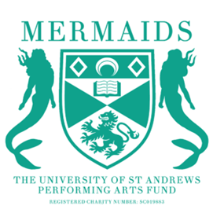
Mermaids Semester 1 Proposal Information
2026-2027
Interested in putting on a show next semester? Proposals are officially open!
We will have 6 slots for next semester(!): 1 in the Byre, 2 in the StAge and 3 in the Barron
Byre shows will have Get-In the day before, StAge shows will have Get-In the day before and have the morning after for Get-Out, Barron shows will depend. In your proposal, please let us know which slot you would like as well as any dates you will be unavailable.
HOW TO PROPOSE:
1. You must fill out a proposal form, budget form, risk assessment, and wellbeing and accessibility plan. Please fill out the forms in as much detail as possible! All forms can be found here: https://www.mermaidstheatre.com/proposals
2. You must attend Proposal Office Hours. The time and location will be advertised on Mermaids social media. If you can’t make office hours, please get in contact with us via email, merprodcoordinator@st-andrews.ac.uk.
3. To propose a show, we ask that you have at least a director, producer, and either a publicity coordinator or technician. If you are struggling to find team members, we encourage you to make use of the Mermaids Community Facebook Group to find potential team members! You can join here https://www.facebook.com/groups/875026180409417/
4. Completed proposals should be emailed to merprodcoordinator@st-andrews.ac.uk by 23:59 18th of April.
Proposals meetings will be scheduled for the 19th of April.

When putting together your proposal, please be aware that Mermaids are not constitutionally permitted to pass shows based on artistic merit. We absolutely want to hear all your exciting ideas, but our priorities when passing shows are 1. budget feasibility 2. production feasibility 3. quantity/quality of opportunities offered to the St Andrews drama scene. More information on our criteria for passing shows can be found on the proposal form!

If you have any questions or would like to arrange an alternative meeting time if you cannot make office hours, please email Ruby our Productions Coordinator (merprodcoordinator@ast-andrews.ac.uk). Happy proposing!

