PRODUCTION / ACTIVITY:

DATES OF ACTIVITY: | ASSESSMENT DATE:
ASSESSED BY:  CONTACT: | APPROVED BY:  DATE:

Activity | Hazard  List hazards here | Who might  be Harmed  list persons | Initial Risk  Rating  L x S | Control Measures  What are you doing to mitigate against the risk | Risk Rating  L x S | Further  Action Required
Emergency evacuation | Lack of knowledge in case of emergency evacuation | Everyone | 2 x 5 = 10 | - Safety induction on arrival at the theatre mandatory for all cast and crew to ensure all persons are aware of fire exits | 1 x 5 = 5 | The venue staff are responsible for evacuating the building the event of an emergency
Trips or fall | Audience, crew or actors trip over set items, props, spilled food, each other or themselves and potentially injure themselves or others. Enhanced risk for female actors wearing heels and long dresses. | All persons involved in activity. | 3 x 3 = 9 | - Practice good housekeeping; keep areas clean & tidy. Ensure walkways are not obstructed. Clean up any spills as soon as is practicable.  - Ensure any trailing cables do not pose a hazard.  - Ensure backstage blues are on before losing working light  - Taping loose cables to the floor,  - Marking out any places with the hazard (i.e change in level) with white tape,  - If blocking involves fast-paced movement, dancing, or running. Ensure enough rehearsal time is given to block out scenes safely  - Food and drink prohibited from stage and backstage areas | 2 x 3 = 6 | The production team is responsible for action.
Fast movement on stage | Actors running, or moving quickly on stage fall or collide with each other | Cast | 3 x 2 = 6 | - Adequate rehearsal time to be assigned to practice exit and entrances.  - Extra attention to be given to blocking.  - This will be done on the main stage before the shows so that the cast is comfortable with the set and the stage.  - Crew to ensure that no objects obstruct the way of the actors | 2 x 2 = 4
Straining | Staff, cast and crew may sustain injury from sharp movements | All persons involved in activity. | 4 x 1 = 4 | - Ensuring actors are properly warmed up for strenuous activity.  - Establish before lifting if there is a risk of straining.  - Assign correct number of people to handle heavier sets and objects. | 3 x 1 = 3
Manual handling (lifting & carrying) | May sustain injury to cast and crew whilst performing and changing the set | Cast and Crew | 4 x 2 = 8 | - No one should attempt to move anything beyond their personal lifting capability.  - Set up/Pack up should be undertaken by at least 2 people.  - Use a trolley for large or heavy loads.  - Appropriate footwear should be worn.  - Gloves available from byre technicains on request | 3 x 2 = 6 | The production team is responsible for action.
Rigging | Injury or damage to property from falling set/equipment | Byre staff | 3 x 2 = 6 | Byre staff will rig all required set and technical equipment in accordance with venue rigging and work at height safe systems of work | 2 x 2 = 4 | The Byre staff is responsible for this action.
Collision in the wings | Actors/stage crew bumping into each other in wings and coming on / off stage | Actors and crew | 4 x 1 = 4 | - Maintaining awareness of surroundings.  - Those in wings anticipating when those on stage will be coming on/off. | 3 x 1 = 3 | Actors/stage crew responsible for this.
Dim lighting or blackout | Actors and crew bumping into each other on or offstage | Actors and crew | 3 x 1 = 3 | - Maintaining awareness of surroundings and being careful of movements during blackouts.  - Ensure blues lighting in on in wings and dock before working light is switched off | 2 x 1 = 2 | Actors/stage crew responsible for this.
*Additional risks associated with your show should be added to this RA following the dim lighting/blackout risk.

Method of Communicating assessment: Building induction / Senior Members of team on shift during initial shifts

Signed:

RISK ASSESSMENT - GUIDANCE NOTES

action | Hazard  (Something with the potential to cause harm) | Persons At Risk  (Someone at risk from the hazard) | Is The Risk Adequately Controlled  (What are the existing controls) | What Further Action Needed to Control Risk  (What more could reasonably be done)
Examples | *Examples | *Examples *Particularly | *Examples
Crowd safety  Access equipment  - Ladder  - MEWP  Using electrical item  - Tools  - Lighting  - Sound  Fit ups  - Unloading vehicles  - rigging  - Building set  - Manual  Working on a rake  Working outside | Slippage / Tripping  Fire (flammable substances)  Ergonomic  Moving Parts  Working at Height  Vehicles  Electrical wiring  Noise  Manual handling  Fumes  Dust  Chemicals | Office Staff  . Freelancers  Audience  Cleaners  Maintenance  *Contractors  *Visitors  The Public  Operators  *Young  *inexperienced  *Trainees  *People working alone  *The Disabled | Is there adequate information / training?  Are there adequate systems / procedures?  Meet legal requirements?  Meet Byre Standards?  Comply with industry standards?  Represent good practice?  Reduce risk as far as possible?  * Are you doing all that is reasonably practicable?  * Can I eliminate the hazard?  * If not, how can I control the risk?  * Personal protective clothing should only be used when no other reasonable action exists | * Prioritise for risks affecting large numbers or where serious harm may result  * Consider:  - Remove risk completely  - Try less risky option  - Prevent access to hazard, e.g. guarding  - Reorganise work to reduce exposure  - Issue personal protective clothing  - Welfare facilities - Washing / First Aid  - Administrative controls  * Review with Management. Assign Responsibility and timescales.

Risk Index - Calculated by multiplying Severity (S) of Hazard by Likelihood (L) of it occurring

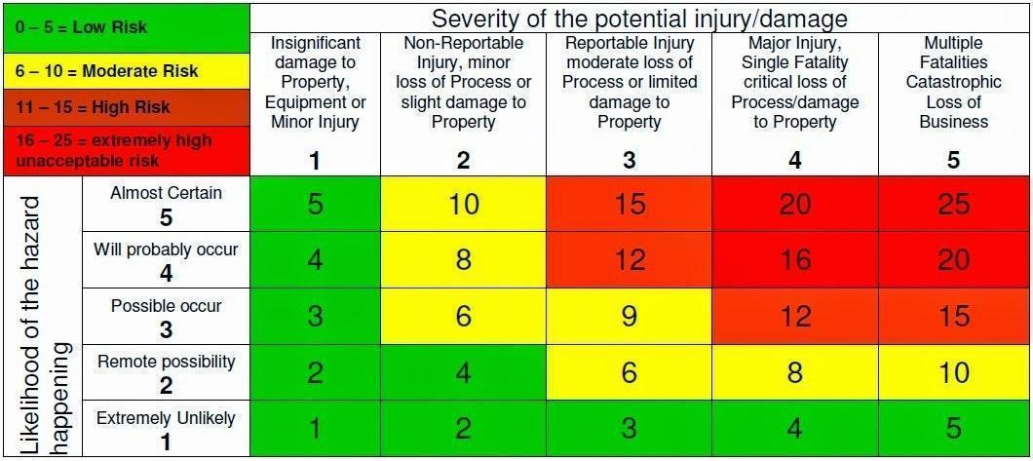

I confirm that the significant findings of the assessments in this file have been communicated to me and the control measures explained. I understand the legal requirements for me to comply with the control measures and to co-operate with my employer in the interest of health and safety. I agree to abide with the controls in place and to report any defects or problems with the systems.

Employee Name | Employee Signature | Date

