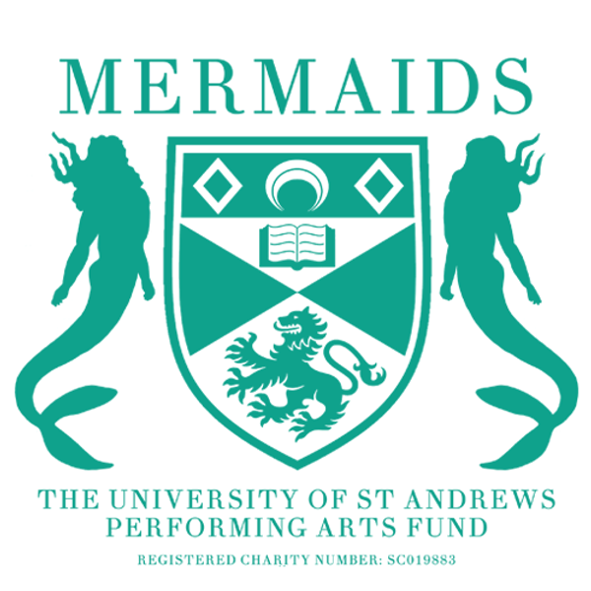

Semester 2
Production Proposal Form
2025-2026

As a matriculated student of the University of St Andrews, you have the opportunity to propose any show to the Mermaids Performing Arts Fund, and we will do everything we can to try and help you make it a reality.

To propose a show to Mermaids, you need to fill in a:
- Production Proposal Form: For help with filling out the proposal form (this document), don’t hesitate to contact our Productions Coordinator, Helena Rothery at merprodcoordinator@st-andrews.ac.uk.
- Budget Form: for advice on filling out the Budget Form, contact the Mermaids Productions Treasurer, Lucy Callaghan (mermtreasurer@st-andrews.ac.uk)
- Risk Assessment Form: for advice on filling out the Risk Assessment Form, contact the Mermaids Technical and Safety Officer, Lara Hickman (ldh6@st-andrews.ac.uk)
- Wellbeing and Accessibility Plan: for advice on filling out the Wellbeing and Accessibility Plan, contact the Vice-President, Erin Loftus-Reid (elr9@st-andrews.ac.uk).
- You also need to attend proposal office hours. Times will be advertised on Mermaids Social Media. If you can’t make the times, please get in touch with Productions Coordinator, Helena merprodcoordinator@st-andrews.ac.uk.

Please ensure you include as much detail as possible, particularly in Section 3 (production ideas). The more details you include, the more likely it is that we will be able to pass your show. To hopefully help make it clearer what we look at when we discuss proposals, below are all the merits that we are constitutionally allowed, and obliged, to consider when choosing our shows:

- Financial Merit: Successful proposals will have all spendings adequately accounted for, ideally with a maximum break-even percentage of 66%.
- Logistical Merit: Successful proposals must suit Mermaids available venue space and show dates, be logistically viable in terms of actor demands and further resources needed for the show and be suitable from a wellbeing perspective.
- Skills-based merit: Successful proposals should provide opportunities for students to enhance their knowledge and skills in performing arts and show potential for improved engagement with wider areas of the St Andrews student community.

Please submit your proposal documents to merprodcoordinator@st-andrews.ac.uk by 23:59 20th November

SECTION 1: PRODUTION DETAILS

Name of Production:
Author:

Why this play?

Forty Word Blurb (including title):

Proposed Dates:

Proposed Venue:
(Contact the Barron Manager, Carrie Cheung, for advice about proposing for the Barron at the Byre barron@st-andrews.ac.uk)

Would you be willing to cast gender-blind/gender-neutral?

Cast numbers (male/female/neutral parts):

Approximate run time:

Do you require Production Rights for this piece?

If yes, have they been requested? *Please attach any correspondence*
Advice on requesting Production Rights:
Email the licensor of the rights, stating that you are a student looking to put on an amateur student production of this show, stating your proposed venue and timeframe (ie Autumn 2025). Ask if these rights will be available.
Do not panic if you get an unclear answer.
Screenshot the entire email thread and insert it here.

Owner/Handler of Rights and Contact Details:

Will you be seeking funding from another body to support this production? (Antony Tudor, for instance).

SECTION 2: MUSIC RIGHTS

As of Autumn 2024, any Mermaids proposals for the Barron or the Byre must budget for music rights. Please answer the following questions.

Will you be using music in your production? YES / NO
Please note that this does not apply to any music played as the audience enters, prior to the beginning of the play/the curtain rising.

If ‘NO’, leave the rest of this section blank.

Is the music 100% originally composed for your production? YES / NO

If ‘YES’, leave the rest of this section blank.

Is the music: INCIDENTAL / INTERPOLATED / BOTH

Have you received permission to use any interpolated music? YES / NO

Note: permission is not required or expected for a proposal, only once the show is passed.

Definitions:

Incidental or ‘curtain’ music: Incidental music refers to music that is not performed by, or audible to a character within the dramatic performance. It is music that may transition a scene change, refer to an underscore or music played at curtain raising or closure.

If using incidental music, a blanket charge of £16.36 (currently) applies, which must be factored into your budget.

Interpolated music: Interpolated music refers to music is part of the drama and it is audible to characters, even if they don’t directly react to it, although they may (eg humming, singing, dancing).

If using interpolated music a more complex system applies, discuss with our Production Coordinator Helena (merprodcoordinator@st-andrews.ac.uk), and she will be able to help you find out how much money you should include in your proposed budget. However, the specific amounts per-minute of interpolated music used can be found here: T-2019-01 Tariff

SECTION 3: PRODUCTION TEAM

All production teams must have a Director and Producer, and Publicists (this role can be doubled up for Barron), or Technician (for advice on finding a technician, contact the Mermaids Technical and Safety Officer, Lara Hickman (ldh6@st-andrews.ac.uk) in order to propose. Once passed, production teams must also have a Wellbeing Coordinator (see Wellbeing and Accessibility Plan).

We would also suggest having a Stage Manager, Costumer and Set Designer should your show need these team members. Please tell us about your team’s previous experience in as much detail as possible and include contact information. If you are proposing as a production company, please mention this here, too!

Director (Name/Email):

Producer (Name/Email):

Publicist (Name/Email):

Technician (Name/Email):

Other Team Members (Name/Email):

SECTION 4: PRODUCTION IDEAS

This section gives us a chance to share your creative vision for the production and understand your budget form in more detail. We do not expect your ideas to be set in stone at this early point, but we hope your budget won’t change drastically from what is passed, so think through what you need and please cross-reference to your production budget. The best way to think about this is to present an act-by-act breakdown of your needs. Please contact the appropriate committee members (details below) to check that your estimates are realistic.

Set: (Contact the Mermaids Set & Props Officer, Lily McCarthy (merprops@st-andrews.ac.uk)

Props: (Contact the Mermaids Set & Props Officer, Lily McCarthy (merprops@st-andrews.ac.uk)

Costumes: (Contact the Mermaids Costumes Officer, Elena Bello (mercostumes@st-andrews.ac.uk )

Make-up and Hair: (Contact the Mermaids Costumes Officer, Elena Bello (mercostumes@st-andrews.ac.uk)

Lighting: (Contact the Mermaids Technical and Safety Officer, Lara Hickman (ldh6@st-andrews.ac.uk)

Sound: (Contact the Mermaids Technical and Safety Officer, Lara Hickman (ldh6@st-andrews.ac.uk)

SECTION 5: MARKETING PLAN

Include ideas for how you would market your play. Include ideas for graphic design and both social media and any physical publicity. Also consider the timeframe of your marketing, and any events (ie film screening) you may run. Cross-reference with your budget. Additionally, seek advice from our website https://www.mermaidstheatre.com/marketing-informations. (Contact the Mermaids Marketing Officer, Elise Siddiqui for advice at mermarketing@st-andrews.ac.uk)

SECTION 6: ENGAGEMENT AND OUTREACH

Please detail any ideas to collaborate with other societies, subcommittees, or charities. This could include joint events such as socials or discussions, awareness talks, common publicity or including them in the programme. Furthermore, please attach any correspondence you have had with them. Please explain how these actions will expand your reach within the student body and engage new sets of students. (Contact the Mermaids Engagement Officer Lila Ahnger for advice at mermsengagement@st-andrews.ac.uk).

SECTION 7: COMMITTEE CORRESPONDENCE

Who on the committee have you spoken to already?
If relevant, attach correspondence.

Committee Contact Details:

President: Bella Hirst (merpres@st-andrews.ac.uk)
Vice President: Erin Loftus-Reid (elr9@st-andrews.ac.uk )
Secretary 2024-25: Roslyn Bates (mermaids@st-andrews.ac.uk)
Productions Treasurer: Lucy Callaghan (mermtreasurer@st-andrews.ac.uk)
Productions Coordinator: Helena Rothery (merprodcoordinator@st-andrews.ac.uk)
Fringe Representative: Amelia Thompson (agt6@st-andrews.ac.uk)
Barron Manager: Carrie Cheung (barron@st-andrews.ac.uk)
Tech and Safety Officer: Lara Hickman (ldh6@st-andrews.ac.uk)
Operations Manager: Ruby Thake (ret9@st-andrews.ac.uk)
Christmas Ball Convenor: Eilidh Read
Box Office Manager Amalia Villegas (barronboxoffice@st-andrews.ac.uk)
Marketing Officer Elise Siddiqui (mermarketing@st-andrews.ac.uk)
Engagements Officer: Lila Ahnger (mermsengagement@st-andrews.ac.uk)
Costumes Officer Elena Bello (mercostumes@st-andrews.ac.uk)
Set & Props Officer, Lily McCarthy (merprops@st-andrews.ac.uk)

