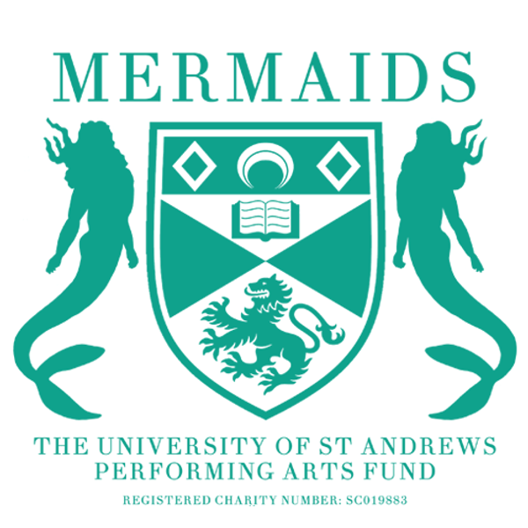
Semester 2
Production Proposal Form
2023-2024

As a matriculated student of the University of St Andrews, you have the opportunity to propose any show to the Mermaids Performing Arts Fund, and we will do everything we can to try and help you make it a reality. The Fresher’s Drama Festival is a weeklong festival where Freshers to Theatre put on multiple Productions throughout this time and gain amazing firsthand experience in being part of a Production Team.

At this stage, you need to fill in this Production Proposal Form, a Budget Form (for advice on filling out the Budget Form, contact the Mermaids Productions Treasurer, Louise Anderbjӧrk, mermtreasurer@st-andrews.ac.uk), a Risk Assessment Form (for advice on filling out the Risk Assessment Form, contact the Mermaids Technical and Operations Officer, Heather Tiernan, ht47@st-andrews.ac.uk) and a Wellbeing Plan (for advice on filling out the Wellbeing Plan, contact the Vice-President, Taylor Colbeth, tnc1@st-andrews.ac.uk).

Please ensure you include as much detail as possible, particularly in Section 3 (production ideas) – the more you have, the more likely we will fund your play.

If you have any questions or concerns, don’t hesitate to email our Productions Coordinator, Jacob Carey, merprodcoordinator@st-andrews.ac.uk, and they’ll help you. This should be submitted accompanied by a completed Budget Form, Risk Assessment, and Wellbeing Plan to the Productions Coordinator by Midnight on the 16th of November.

Section 1: Production Details

Name of Production:
Author:

Why this play?

Forty Word Blurb (including title):

Proposed Dates:

Proposed Venue:
(Contact the Barron Manager, Alice Banks for advice about proposing for the Barron at the Byre barron@st-andrews.ac.uk)

Would you be willing to cast gender-blind/gender-neutral?

Cast numbers (male/female/neutral parts):

Approximate run time:

Do you require Production Rights for this piece?

If yes, have they been requested? *Please attach any correspondence*

Owner/Handler of Rights and Contact Details:

Will you be seeking funding from another body to support this production? (Antony Tudor, for instance).

Section 2: Production Team

All production teams must have a Director, Producer, Publicists (this role can be doubled up for Barron), or Technician (for advice on finding a technician, contact the Mermaids Technical and Operations Officer, Heather Tiernan, ht47@st-andrews.ac.uk).

We would also suggest having a Stage Manager, Costumer and Set Designer should your show need these team members. Please tell us about your team’s previous experience in as much detail as possible and include contact information. If you are proposing as a production company, please mention this here, too!

Director (Name/Email):

Producer (Name/Email):

Publicist (Name/Email):

Technician (Name/Email):

Other Team Members (Name/Email):

Section 3: Production Ideas

This gives us a chance to share your creative vision for the production and understand your budget form in more detail. We do not expect your ideas to be set in stone at this early point, but we hope your budget won’t change drastically from what is passed, so think through what you need. The best way to think about this is to present an act-by-act breakdown of your needs. Please meet with the appropriate committee members (details below) to check that your estimates are realistic.

Set:
(Contact the Mermaids Set & Props Officer, Bella Hirst, for advice at merprops@st-andrews.ac.uk):

Props:
(Contact the Mermaids Set & Props Officer, Bella Hirst, for advice at merprops@st-andrews.ac.uk):

Costumes:
(Contact the Mermaids Costumes and Make-up Officer, Gretchen Mills, for advice at gm308@st-andrews.ac.uk):

Make-up and Hair:
(Contact the Mermaids Costumes and Make-up Officer, Gretchen Mills, for advice at gm308@st-andrews.ac.uk):

Lighting:
(Contact the Mermaids Technical and Operations Officer, Heather Tiernan, for advice at ht47@st-andrews.ac.uk):

Sound:
(Contact the Mermaids Technical and Operations Officer, Heather Tiernan, for advice at ht47@st-andrews.ac.uk):

Section 4: Marketing Plan:

Please include ideas for how you would market your play. Include ideas for graphic design and both social media and any physical publicity. (Contact the Mermaids Marketing Officer, Amalia Villegas, for advice at av92@st-andrews.ac.uk)

Section 5: Engagement and Outreach

Please detail any ideas to collaborate with other societies, subcommittees or charities. This could include joint events such as socials or discussions, awareness talks, common publicity or including them in the programme. Furthermore, please attach any correspondence you have had with them. Please explain how these actions will expand your reach within the student body and engage new sets of students. Whilst it is unnecessary, we encourage collaboration and support other societies, subcommittees and charities. (Contact the Mermaids Engagement Officer, Eleanor Whorms, for advice at ew239@st-andrews.ac.uk)

Section 6: Committee Correspondence

Who on the committee have you spoken to already?

Committee Contact Details:
President: Marisa Singh (merpres@)
Vice President: Taylor Colbeth (tnc1@)
Productions Coordinator: Jacob Carey (merprodcoordinator@)
Productions Treasurer: Louise Anderbjörk (mermtreasurer@)
Barron Manager: Alice Banks (barron@)
Technical and Operations Officer: Heather Tiernan (ht47@)
Set and Props Officer: Bella Hirst (merprops@)
Costumes and Make-up Officer: Gretchen Mills (gm308@)
Marketing Officer: Amalia Villegas (av92@)
Engagement Officer: Eleanor Whorms (ew239@)
Box Office Manager: Isabel Alexander (barronboxoffice@)
Christmas Ball Convener: Abby Kelley (christmasball@)
Secretary: Sarah Garde (mermaids@)
Fringe Representative: Eleanor Reid (mermaidsfringe@)
Director of Events and Services: Lucy Brook (does@)
Director of Student Development and Activities: Sam Gorman (dosda@)

