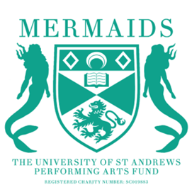
Mermaids Semester 1 Proposal Information
2024-2025
Interested in putting on a show next semester? Proposals are officially open!
We have 6 slots for next semester:
- The Byre Theatre week 5 October 15th and 16th (with a get-in on October 14th)
- The St.Age week 8/9 November 10th and 11th (with a get-in on November 9th), and week 10/11 November 24th and 25th (with a get-in on November 23rd)
- The Barron at the Byre There will be 3 Barron slots with dates TBD, please state in your proposal whether you would prefer a slot before reading week or after reading week, or if you have no preference.

HOW TO PROPOSE:
1. You must fill out a proposal form, budget form, risk assessment, and wellbeing and accessibility plan. Please fill out the forms in as much detail as possible! All forms can be found here: https://universityofstandrews907.sharepoint.com/:f:/s/MermaidsCommittee2425/EgOcYMTdphdMpOk89mCcNmwB470xQ62hgg5AyFScIa0XUw?e=WmwWEq
2. You must attend one of these office hours slots to discuss your proposal before the deadline: 9th of April, 7:30-8pm, or 16th of April 6-8pm. If you can’t make office hours, please get in contact with us via email.
3. To propose a show, we ask that you have at least a director, producer, and either a publicity coordinator or technician. If you are struggling to find team members, we encourage you to make use of the Mermaids Community Facebook Group to find potential team members! You can join here https://www.facebook.com/groups/875026180409417/
4. Completed proposals should be emailed to lt209@st-andrews.ac.uk by noon on April 17th.
Proposals meetings will be scheduled for April 19th.

When putting together your proposal, please be aware that Mermaids are not constitutionally permitted to pass shows based on artistic merit. We absolutely want to hear all your exciting ideas, but our priorities when passing shows are 1. budget feasibility 2. production feasibility 3. quantity/quality of opportunities offered to the St Andrews drama scene. More information on our criteria for passing shows can be found on the proposal form!

If you have any questions or would like to arrange an alternative meeting time if you cannot make office hours, please email Lucy our Productions Coordinator (lt209@st-andrews.ac.uk). Happy proposing!

