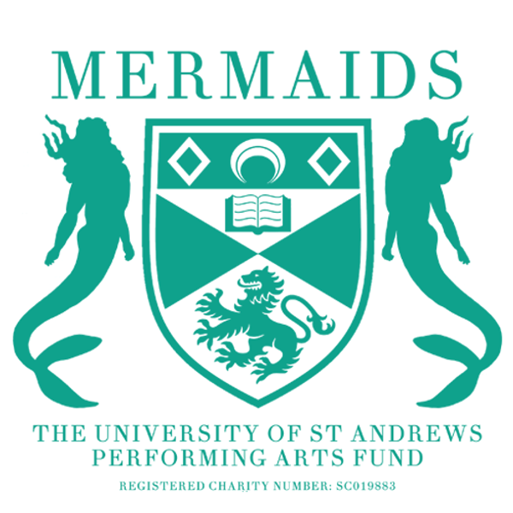

Semester 1
Production Proposal Form
2024-2025

As a matriculated student of the University of St Andrews, you have the opportunity to propose any show to the Mermaids Performing Arts Fund, and we will do everything we can to try and help you make it a reality.

To propose a show to Mermaids, you need to fill in a:
- Production Proposal Form: For help with filling out the proposal form (this document), don’t hesitate to contact our Productions Coordinator, Lucy Turner lt209@st-andrews.ac.uk.
- Budget Form: for advice on filling out the Budget Form, contact the Mermaids Productions Treasurer, Erin Loftus-Reid (elr9@st-andrews.ac.uk)
- Risk Assessment Form: for advice on filling out the Risk Assessment Form, contact the Mermaids Technical and Safety Officer, Sofia David (asd20@st-andrews.ac.uk)
- Wellbeing and Accessibility Plan: for advice on filling out the Wellbeing and Accessibility Plan, contact the Vice-President, Bella Hirst (ih64@st-andrews.ac.uk).
- You also need to attend one of our proposals office hours on the 9th of April, 7:30-8pm, or 16th of April 6-8pm

Please ensure you include as much detail as possible, particularly in Section 3 (production ideas). The more details you include, the more likely it is that we will be able to pass your show. To hopefully help make it clearer what we look at when we discuss proposals, below are all the merits that we are constitutionally allowed, and obliged, to consider when choosing our shows:

- Financial Merit: Successful proposals will have all spendings adequately accounted for, ideally with a maximum break-even percentage of 66%.
- Logistical Merit: Successful proposals must suit Mermaids available venue space and show dates, be logistically viable in terms of actor demands and further resources needed for the show and be suitable from a wellbeing perspective.
- Skills-based merit: Successful proposals should provide opportunities for students to enhance their knowledge and skills in performing arts, and show potential for improved engagement with wider areas of the St Andrews student community.

Please submit your proposal documents to lt209@st-andrews.ac.uk by noon on the 17th of April 2024.

SECTION 1: PRODUTION DETAILS

Name of Production:
Author:

Why this play?

Forty Word Blurb (including title):

Proposed Dates:

Proposed Venue:
(Contact the Barron Manager, Alice Banks for advice about proposing for the Barron at the Byre barron@st-andrews.ac.uk)

Would you be willing to cast gender-blind/gender-neutral?

Cast numbers (male/female/neutral parts):

Approximate run time:

Do you require Production Rights for this piece?

If yes, have they been requested? *Please attach any correspondence*

Owner/Handler of Rights and Contact Details:

Will you be seeking funding from another body to support this production? (Antony Tudor, for instance).

SECTION 2: PRODUCTION TEAM

All production teams must have a Director, Producer, Publicists (this role can be doubled up for Barron), or Technician (for advice on finding a technician, contact the Mermaids Technical and Safety Officer, Sofia David (asd20@st-andrews.ac.uk).

We would also suggest having a Stage Manager, Costumer and Set Designer should your show need these team members. Please tell us about your team’s previous experience in as much detail as possible and include contact information. If you are proposing as a production company, please mention this here, too!

Director (Name/Email):

Producer (Name/Email):

Publicist (Name/Email):

Technician (Name/Email):

Other Team Members (Name/Email):

SECTION 3: PRODUCTION IDEAS

This section gives us a chance to share your creative vision for the production and understand your budget form in more detail. We do not expect your ideas to be set in stone at this early point, but we hope your budget won’t change drastically from what is passed, so think through what you need and please cross-reference to your production budget. The best way to think about this is to present an act-by-act breakdown of your needs. Please contact the appropriate committee members (details below) to check that your estimates are realistic.

Set: (Contact the Mermaids Set & Props Officer, Sara Whiteman (sew24@st-andrews.ac.uk)

Props: (Contact the Mermaids Set & Props Officer, Sara Whiteman (sew24@st-andrews.ac.uk)

Costumes: (Contact the Mermaids Costumes Officer, Amelia Thompson (agt6@st-andrews.ac.uk)

Make-up and Hair: (Contact the Mermaids Costumes Officer, Amelia Thompson (agt6@st-andrews.ac.uk)

Lighting: (Contact the Mermaids Technical and Safety Officer, Sofia David (asd20@st-andrews.ac.uk)

Sound: (Contact the Mermaids Technical and Safety Officer, Sofia David (asd20@st-andrews.ac.uk)

SECTION 4: MARKETING PLAN

Please include ideas for how you would market your play. Include ideas for graphic design and both social media and any physical publicity. (Contact the Mermaids Marketing Officer, Cameron Collier for advice at cc345@st-andrews.ac.uk)

SECTION 5: ENGAGEMENT AND OUTREACH

Please detail any ideas to collaborate with other societies, subcommittees, or charities. This could include joint events such as socials or discussions, awareness talks, common publicity or including them in the programme. Furthermore, please attach any correspondence you have had with them. Please explain how these actions will expand your reach within the student body and engage new sets of students. (Contact the Mermaids Engagement Officer Caitie Steele for advice at cs431@st-andrews.ac.uk).

SECTION 6: COMMITTEE CORRESPONDENCE

Who on the committee have you spoken to already?

Committee Contact Details:

President: Louise Anderbjörk (Lsea1@st-andrews.ac.uk)
Vice President: Bella Hirst (ih64@st-andrews.ac.uk)
Secretary: Roslyn Bates (rb308@st-andrews.ac.uk)
Productions Treasurer: Erin Loftus-Reid (elr9@st-andrews.ac.uk)
Productions Coordinator: Lucy Turner (lt209@st-andrews.ac.uk)
Fringe Representative: Robert (RoMo) Moran (rjm34@st-andrews.ac.uk)
Barron Manager: Ami Melville (am648@st-andrews.ac.uk)
Tech and Safety Officer: Sofia David (asd20@st-andrews.ac.uk)
Operations Manager: Carrie Cheung (kwc3@st-andrews.ac.uk)
Christmas Ball Convenor: Lucy Callaghan
Box Office Manager: Amalia Villegas (av92@st-andrews.ac.uk)
Marketing Officer: Cameron Collier (cc345@st-andrews.ac.uk)
Engagements Officer: Caitlin Steele (cs431@st-andrews.ac.uk)
Costumes Officer: Amelia Thompson (agt6@st-andrews.ac.uk)
Set and Props Officer: Sara Whiteman (sew24@st-andrews.ac.uk)

